Chapter 9, Solution 69.

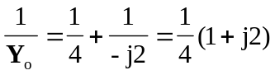

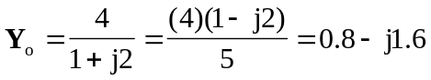

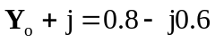

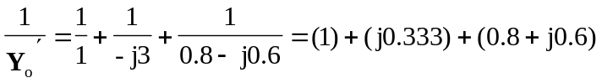
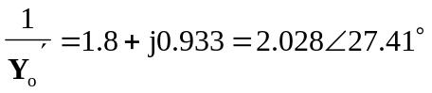

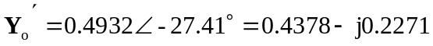

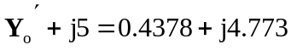

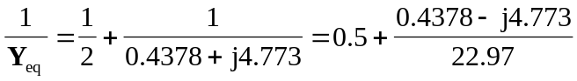
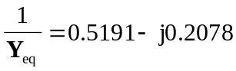

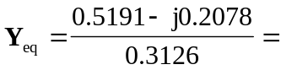 (1.661 + j0.6647) S

